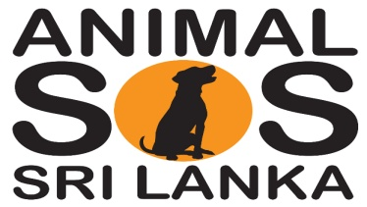
Help Us To Make A Difference. Help Us To Save Lives.

Animal SOS Sri Lanka receives no government or lottery funding and depends entirely on you. We accept donations, monthly Direct Debit, unwanted shares and Gift Aid.

INSTRUCTIONS TO YOUR BANK OR BUILDING SOCIETY TO PAY BY MONTHLY DIRECT DEBIT

I hereby agree to pay Animal SOS Sri Lanka a monthly Direct Debit to Barclays Bank plc, Loughton and Woodford, Ilford Group.

Account name: Animal SOS Sri Lanka. Account Number: 10823767. Sort Code: 20-52-74

I understand that this instruction may remain with Animal SOS Sri Lanka until further notice and details will be passed to my Bank/Building Society.

To: The Manager (Bank or Building Society)
Donors Name:............................................ Address............................................................
Agreed monthly Sum : ...................to be paid to Animal SOS Sri Lanka, UK Registered Charity
Direct Debit Start Date : ……. /……../………..
Donors Bank/Building Society Name : ............................................................................
Branch Address : ..........................................................................................................
Bank Account Number : ............................. Sort Code : .................................................

Signature .......................................... Date ....................................

GIFT AID DECLARATION

There is a way to make your make your donation work even harder. Gift Aid allows us to reclaim the tax you have paid on all your donations to Animal SOS Sri Lanka. We get an extra 25p in the pound from the Inland Revenue. You must be a tax payer in the U.K. paying at least the amount of income tax and/capital gains tax equal to the amount Animal SOS Sri Lanka will reclaim on your tax donations in the tax year.

I wish that Animal SOS Sri Lanka Charity Registered No.1119902 treat all donations I make from this date, and all donations I have made since 10th June 2007 as Gift Aid donations, until I notify you otherwise

Title Mr/Mrs/Ms/Miss First Name ...................... Surname ................................................

Address ...........................................................................................................................

Signature ………………………………………………………………… Date ………………………………………………

Please be kind enough to return your completed form to:
Animal SOS Sri Lanka, 12 Cheyne Avenue, South Woodford, London E18 2DR

CONTACT PREFERENCES

We would like to keep you informed of our progress in Sri Lanka. Please let us know which of the following ways in which we can keep in touch with updates and for special appeals.

□ I am happy to receive all mailings / appeals
□ I would like to receive special appeals only
□ I would prefer not to receive any mailings thank you

